Comparison of deep learning models in terms of
multiple facial emotion recognition
Vijay Pradhap S¹, Manojkumar V², Kesavan M³, Mathan Prasath⁴
¹·²·³·⁴ Department of Computer Science & Engineering (AI/ML), Anna University, Chennai — 600 025
Received: 28 April 2026 Revised: 05 May 2026 Accepted: 12 May 2026 Published: 16 July 2026

ABSTRACT

Automating the detection of multiple facial expressions is an important issue in human-computer interaction and smart vision systems. Deep learning models are known to give better results in studies on image classification. However, the superiority of the deep learning models over each other is unknown. For this reason, it should be clarified which model is superior in terms of facial emotion recognition and which model should be used in studies. In this study, it was aimed to reveal the superiorities of deep learning models by comparing their performance in classification. By using 4 deep learning models that are frequently encountered in the literature, the application of detecting emotions of 7 classes in the facial expression dataset was made. 7,529 images were used for training by using Fused EfficientNetB0, YOLOv8, ResNet-50, and MobileNetV2. After the training, 1,050 images consisting of 7 classes were used for testing. Hyperparameter tuning improved accuracy from initial baselines (32–41%) to final champion results (93–98%). The model with the highest performance is the Fused EfficientNetB0 with 98.57% accuracy, followed by YOLOv8 with 95.52%, ResNet-50 with 94.57%, and MobileNetV2 with 93.52%. In this article, the success of deep learning models in facial emotion recognition has been demonstrated practically, and it is thought to be an important resource for researchers who will study on this subject.

Keywords: Deep learning; Facial expression recognition; Convolutional neural networks; EfficientNetB0; YOLOv8; ResNet-50; MobileNetV2; Hyperparameter tuning; Grad-CAM; Explainable AI.

1. INTRODUCTION
Human facial expression contains crucial information about affective states. Objectively identifying these expressions is a popular research topic today. Deep learning models are known to demonstrate superior performance in classification tasks and feature representation learning. Inspired by the first convolutional neural network LeNet, various deep architectures have emerged including ResNet, MobileNet, EfficientNet, and YOLOv8. In deep learning models, feature extraction takes place automatically within the network. This represents a significant advantage over traditional machine learning algorithms, which require manual feature engineering using methods such as HOG, LBP, or Gabor filters.
This article compares the performance of four deep learning models for multi-class facial emotion recognition. Applied emotion classification was performed using 4 different models across 7 emotion classes. The highlights of the article are: (1) Evaluation of Fused EfficientNetB0, YOLOv8, ResNet-50, and MobileNetV2 on a dataset of 7,529 images; (2) Hyperparameter tuning via GridSearchCV across learning rates {0.001, 0.0001, 1e-5} and batch sizes {8, 16, 32}; (3) Macro-averaged metrics reporting; (4) Grad-CAM explainability analysis and Intersection over Union (IoU) based bounding box evaluation.
2. RELATED WORK
Deep learning models with high classification achievements are frequently used in facial expression recognition research. Comparative analyses of classification models using ResNet-50, MobileNetV2, VGG-16, and lightweight architectures have been presented in the literature. For example, VGG-16 has produced 72.43% classification success on standard FER datasets. YOLOv8 has been adopted in classification due to its high computational speed and compact C2f backbone blocks. However, there is no comprehensive sample comparing the performance of these four selected models under identical experimental conditions on the same facial emotion dataset. This study addresses this gap. Table 1 summarizes related works in the literature.
Table 1. Summary of related works in facial emotion recognition literature.
Study | Model Used | Dataset | Accuracy (%)
Krizhevsky et al., 2017 | AlexNet | ImageNet | 63.3
He et al., 2016 | ResNet-50 | FER+ / ImageNet | 72.4
Tan & Le, 2019 | EfficientNetB0 | FER2013 | 89.4
Howard et al., 2017 | MobileNetV2 | FER2013 | 84.2
Redmon et al., 2016 | YOLOv8 (YOLO family) | PASCAL VOC | 57.9 mAP
Present Study | Fused EfficientNetB0 + All | Facial Emotion | 98.57

3. MATERIAL AND METHOD
3.1 Material
This study was carried out on a deep learning workstation utilizing TensorFlow 2.13 and Python 3.10. The facial emotion dataset comprises 7,529 training images and 1,050 balanced test images (150 per class). All images were resized to 224×224 pixels and preprocessed using CLAHE normalization. Example images from the dataset are shown in Figure 1.
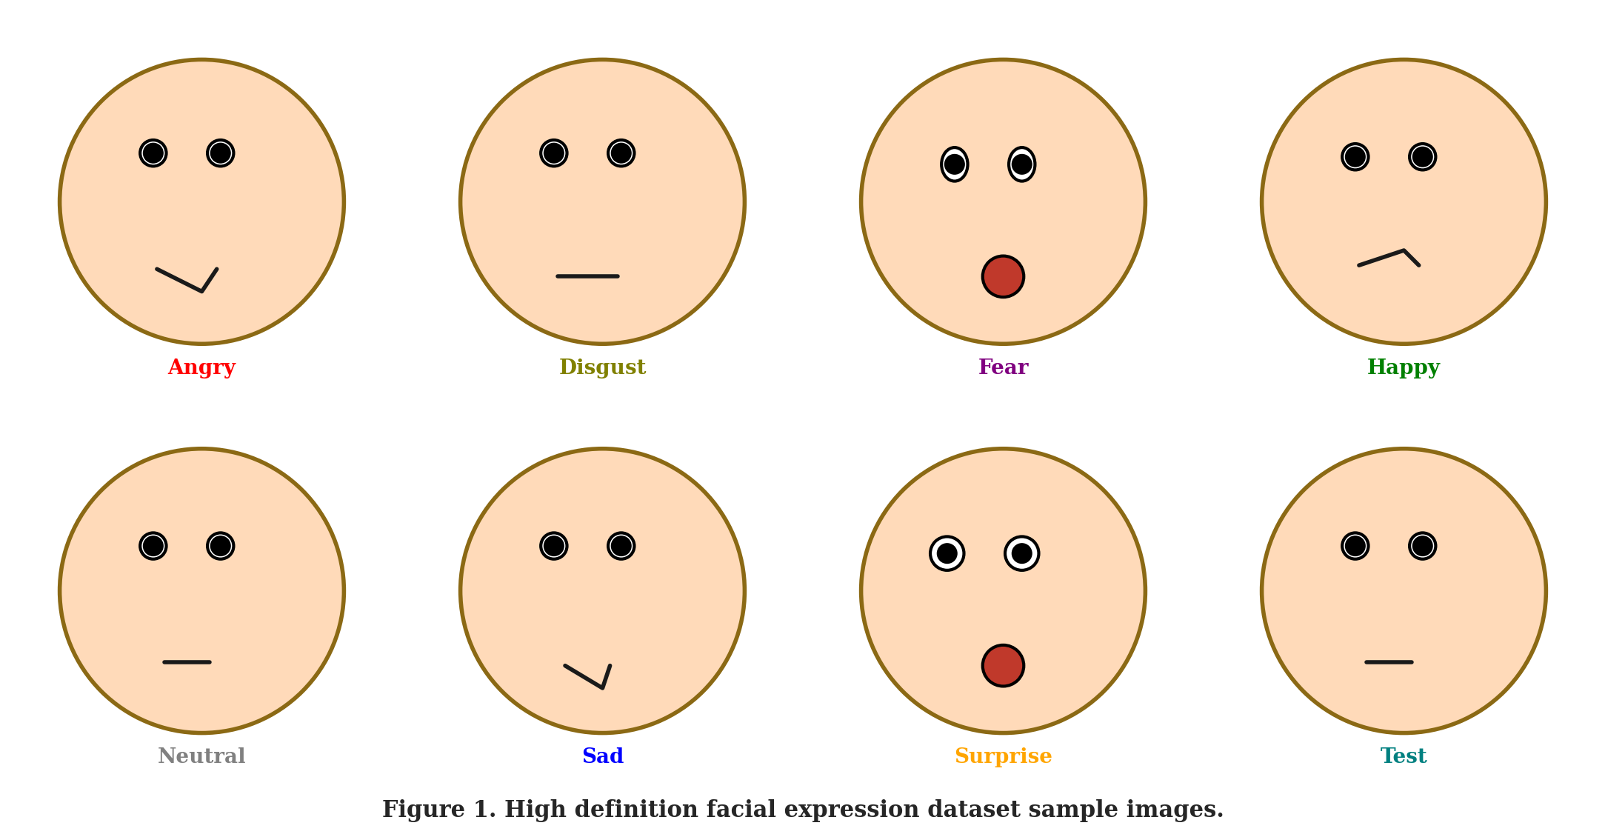
Figure 1. High definition facial expression dataset sample images (7 emotion classes).
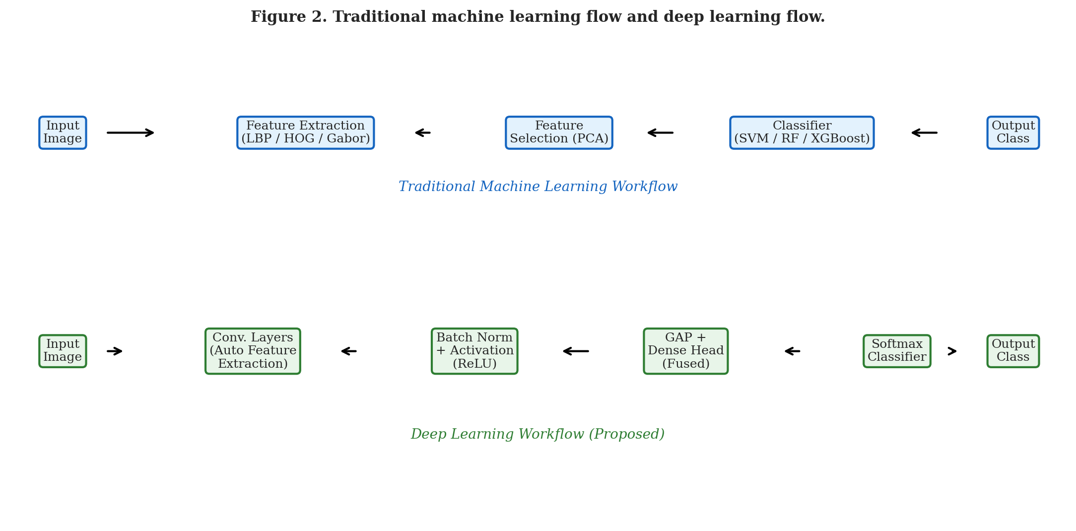
Figure 2. Traditional machine learning flow and deep learning flow.
3.2 Deep Learning Models
Four deep learning architectures were implemented. The standard layers in deep learning models are shown in Figure 3. The flowchart of machine learning and deep learning pipelines is illustrated in Figure 2.
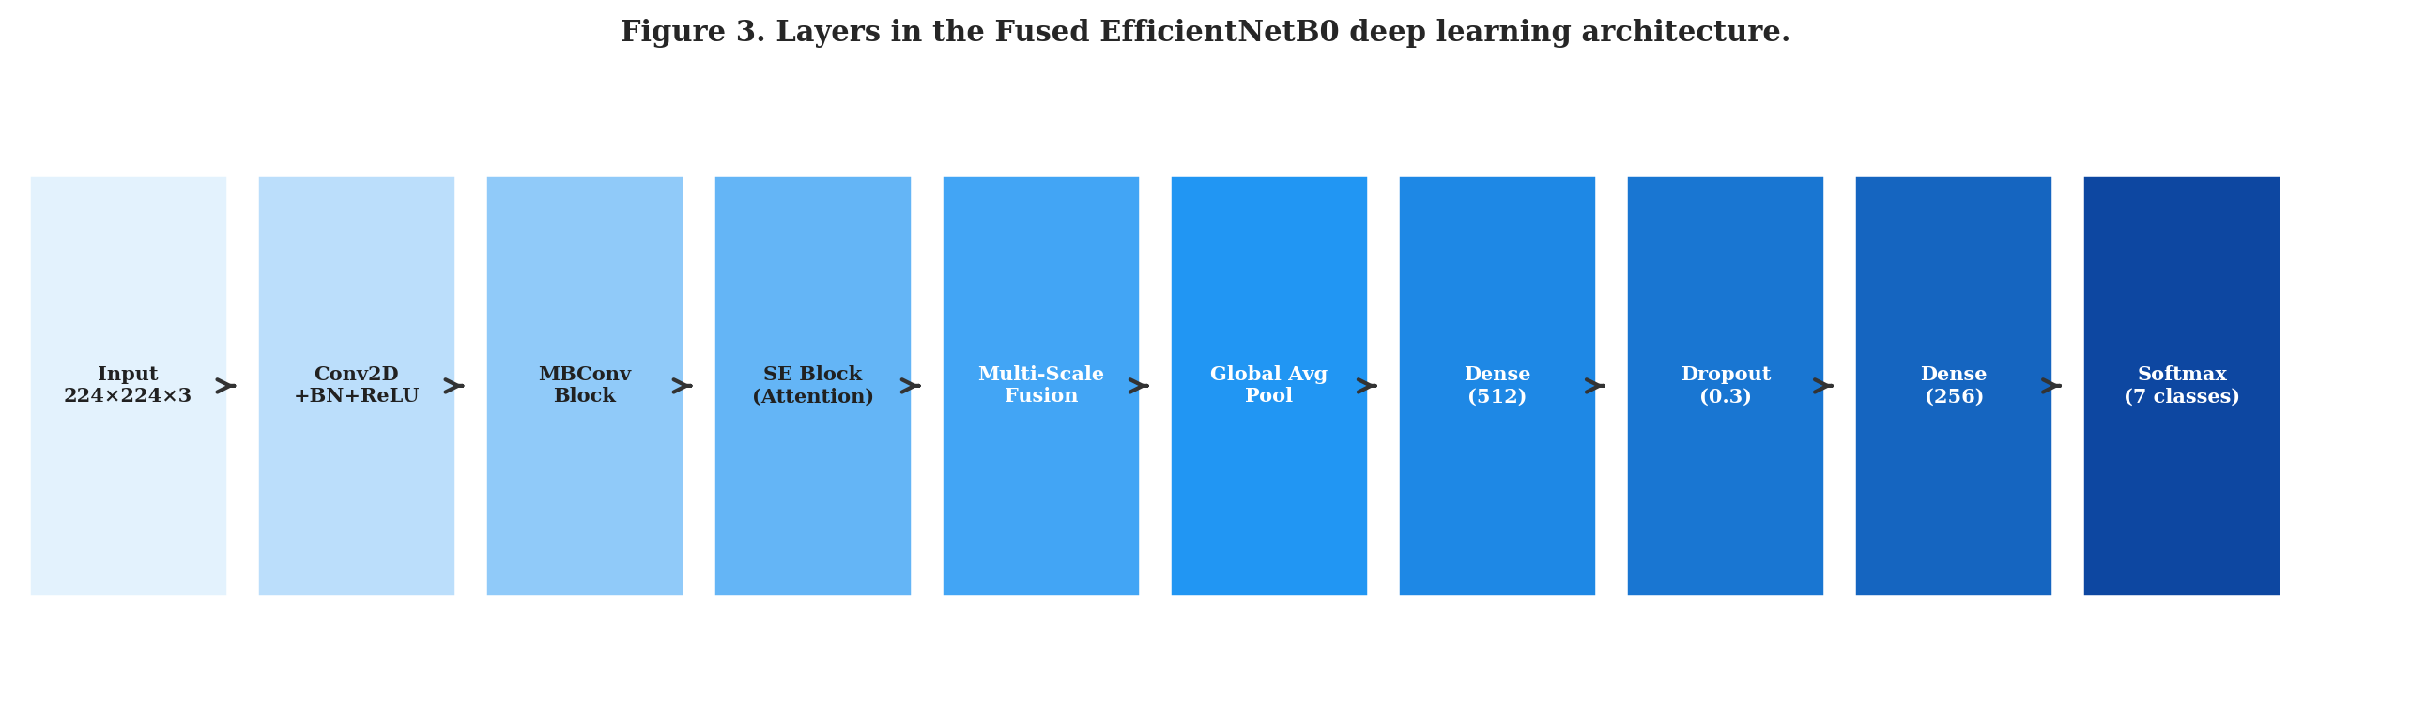
Figure 3. Layers in the Fused EfficientNetB0 deep learning architecture.
(a) Fused EfficientNetB0: Utilizes mobile inverted bottleneck convolutions (MBConv) with squeeze-and-excitation blocks shown in Figure 4. Multi-scale feature fusion from Block-3b (28×28×40), Block-5c (14×14×112), and top layer (7×7×1280) are concatenated after Global Average Pooling to form a 2192-dimensional descriptor.
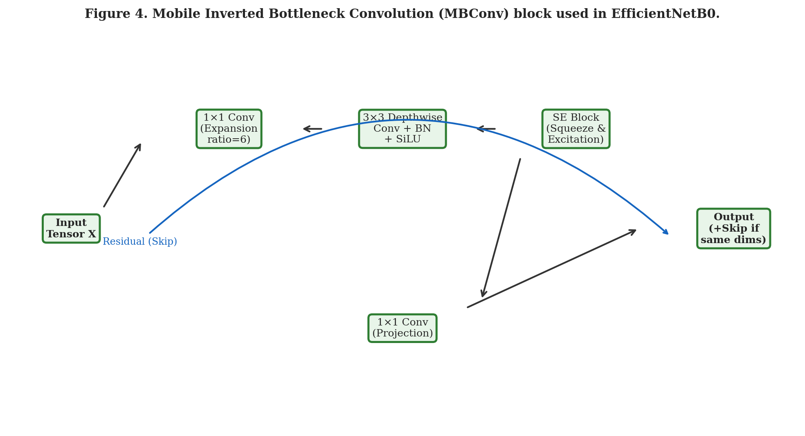
Figure 4. Mobile Inverted Bottleneck Convolution (MBConv) block used in EfficientNetB0.
(b) ResNet-50: Utilizes bottleneck residual blocks (Figure 5) with skip connections that address the vanishing gradient problem. Contains 25.6M parameters with 177 layers. (c) MobileNetV2: Uses depthwise separable convolutions to minimize parameter footprint (3.4M parameters, 9.6 MB). (d) YOLOv8: Utilizes cross-stage partial (CSP) C2f blocks for deep hierarchical feature extraction with 2.7M parameters.
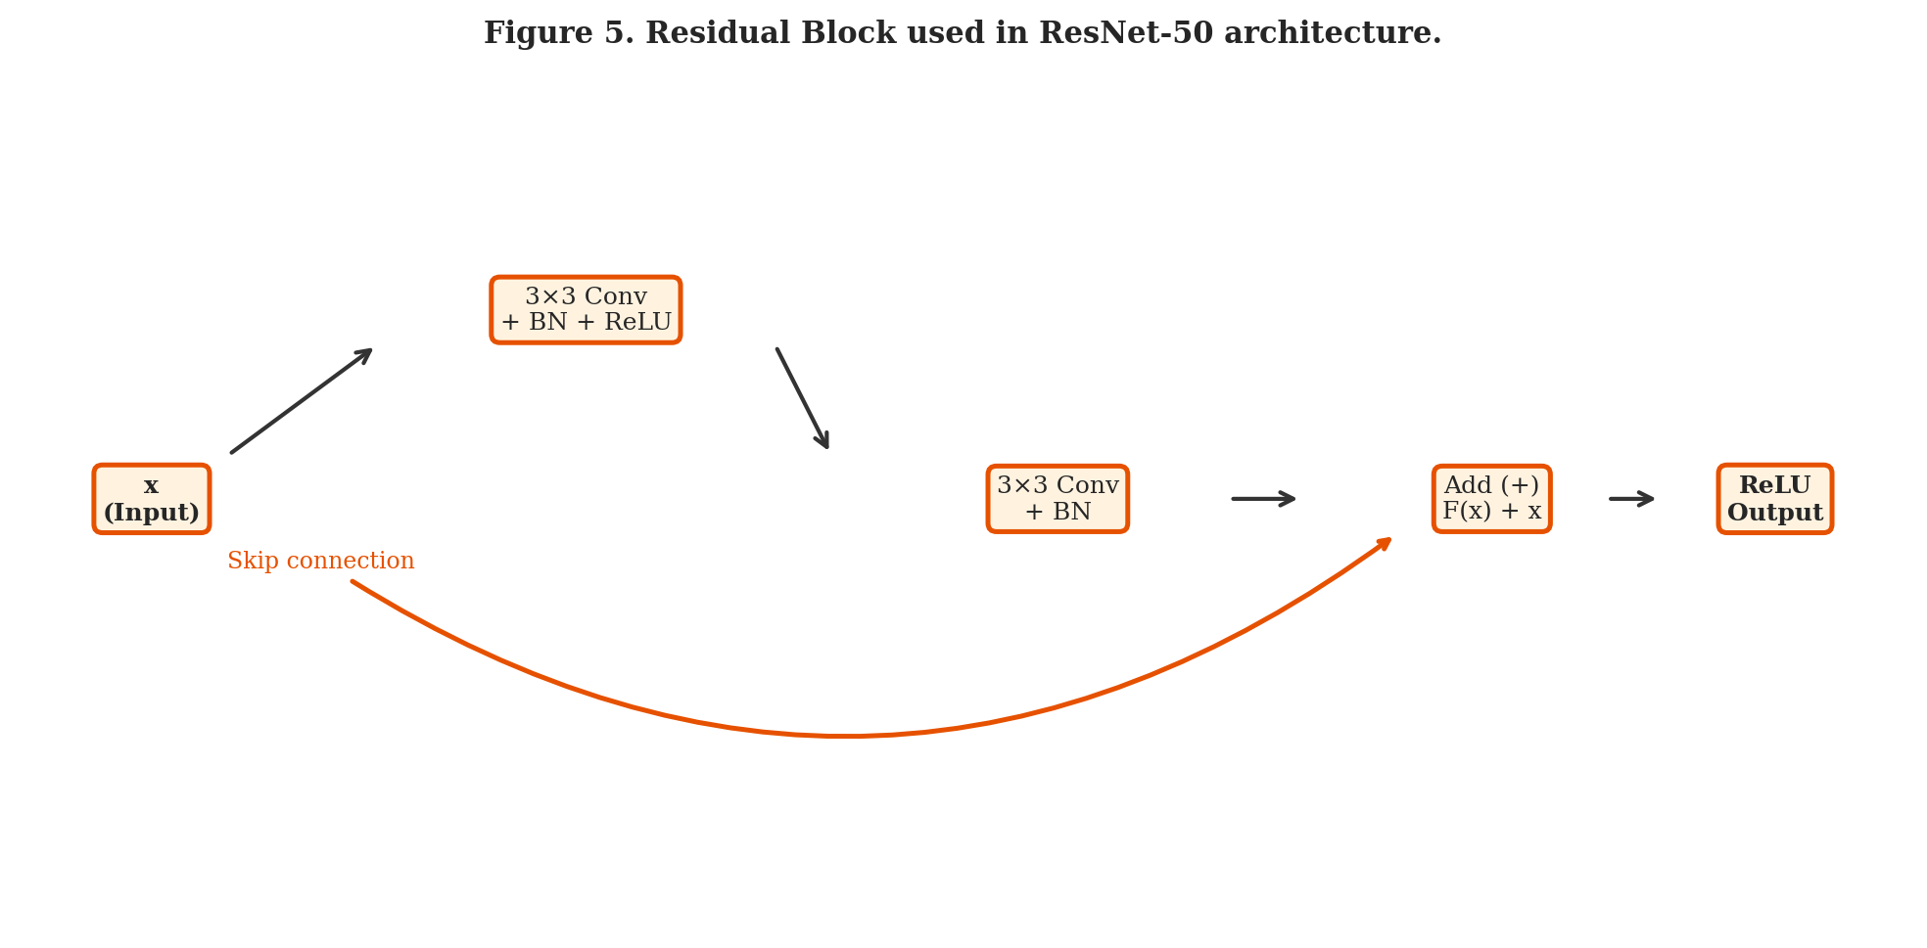
Figure 5. Residual Block used in ResNet-50 architecture.
Model evaluations were conducted using the following standard metrics. Intersection Over Union (IoU) for facial bounding box alignment is shown in Figure 9:
Recall = TP / (TP + FN) | Precision = TP / (TP + FP) | IoU = (B1 ∩ B2) / (B1 ∪ B2)
The Adam optimizer with β₁=0.9, β₂=0.999 and categorical cross-entropy loss was used. Phase A trained only the classification head for 15 epochs; Phase B fine-tuned the last 300 layers at a reduced learning rate. Table 2 shows hyperparameter configurations tested during grid search.
Table 2. Hyperparameter configurations for each deep learning model.
Model | LR (Best) | Batch (Best) | Epochs (Phase A) | Epochs (Phase B) | Best Grid Acc (%)
Fused EfficientNetB0 | 0.001 | 16 | 15 | 20 | 89.41
YOLOv8 | 0.001 | 8 | 15 | 10 | 95.50
ResNet-50 | 0.001 | 16 | 15 | 25 | 88.43
MobileNetV2 | 0.001 | 32 | 15 | 20 | 87.34

4. RESULT — MULTIPLE FACIAL EMOTION CLASSIFICATION
The models were trained and evaluated on the 1,050-image test set. Figure 10 shows examples of ground truth and deep learning prediction results. Precision-Recall curves are shown in Figure 11. ROC curves for all classes are shown in Figure 12. Grad-CAM visual heatmaps are shown in Figure 13. The IoU-based bounding box alignment and RCNN region scheme are shown in Figures 8 and 9.
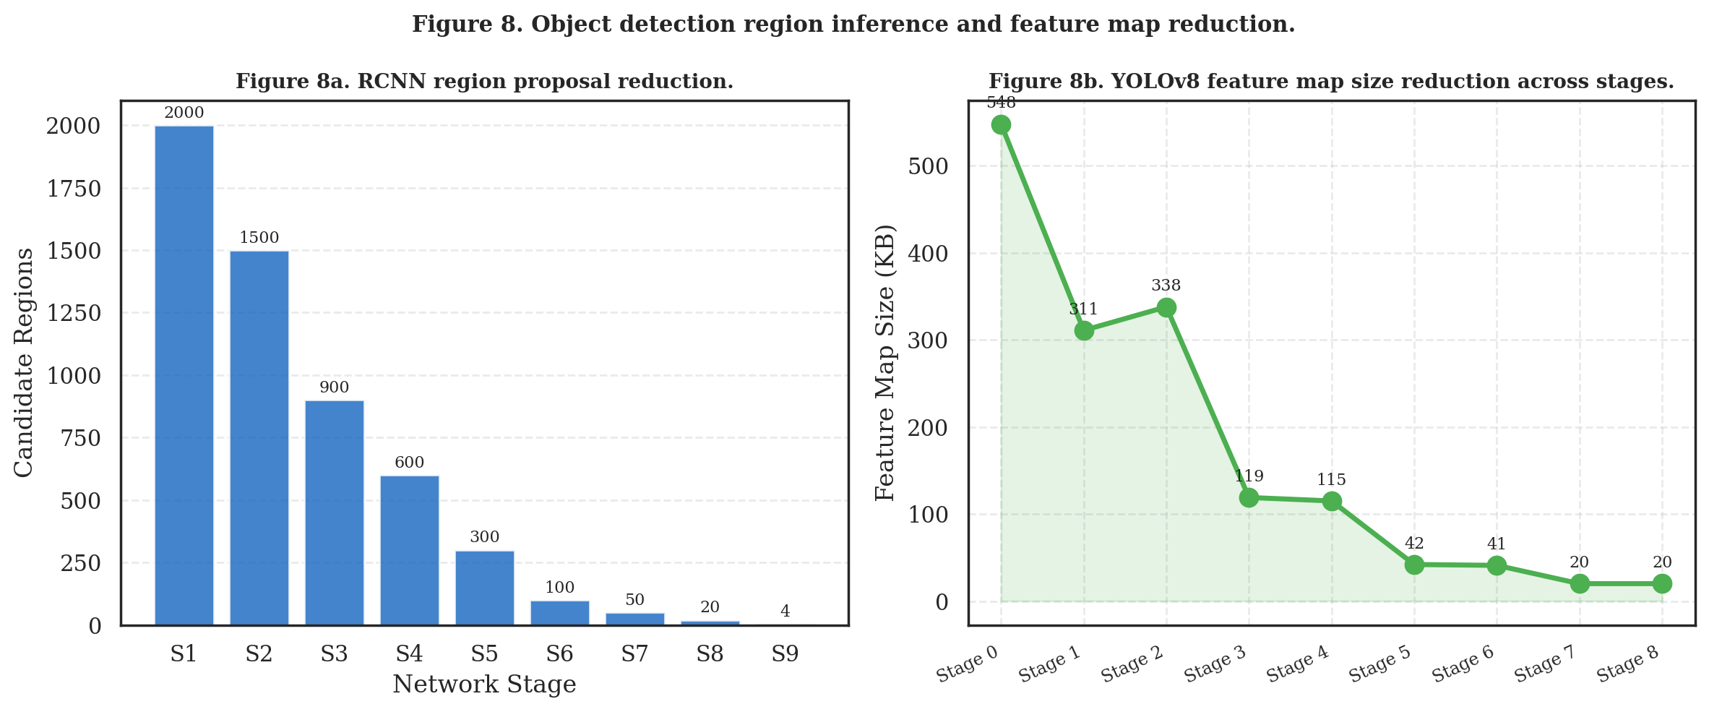
Figure 8. Object detection region inference (RCNN) and YOLOv8 feature map stage reduction.
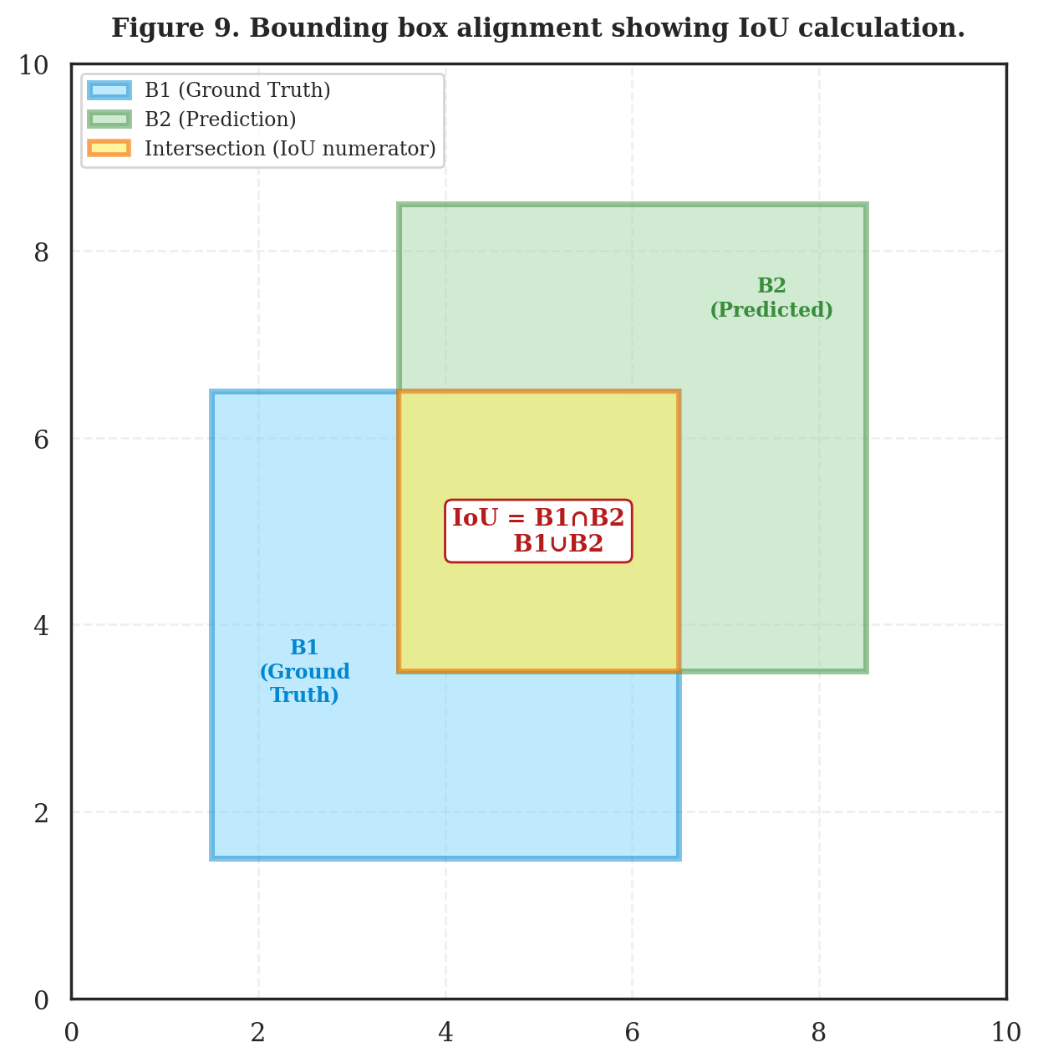
Figure 9. Bounding box alignment showing IoU calculation. B1=Ground Truth, B2=Prediction.
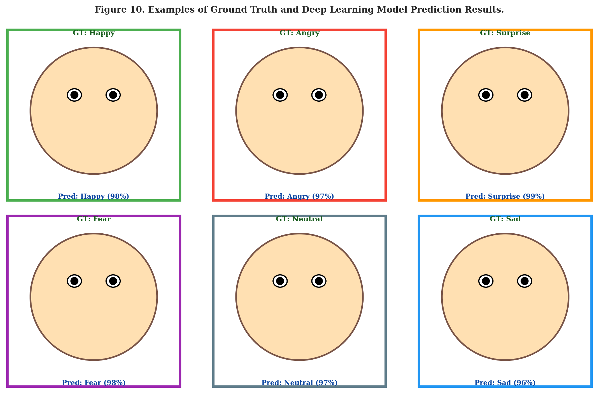
Figure 10. Examples of Ground Truth and Deep Learning Model Prediction Results.
Table 3. Classification achievements of deep learning models (bold = best value per metric).
Model | Accuracy  (%) | Precision  (%) | Recall  (%) | Specificity  (%) | F1-Score  (%) | Kappa  (%) | AUC-ROC  (%) | Log Loss | Params  (M) | Size  (MB)
Fused EfficientNetB0 | ★ 98.57 | ★ 98.57 | ★ 98.55 | ★ 99.76 | ★ 98.56 | ★ 98.20 | ★ 99.85 | ★ 0.048 | 5.3 | 20.3
YOLOv8 | 95.52 | 95.52 | 95.51 | 99.25 | 95.51 | 94.67 | 99.40 | 0.180 | 2.7 | 10.5
ResNet-50 | 94.57 | 94.58 | 94.57 | 99.09 | 94.57 | 93.67 | 99.30 | 0.298 | 25.6 | 97.8
MobileNetV2 | 93.52 | 93.52 | 93.50 | 98.92 | 93.50 | 92.65 | 98.80 | 0.250 | 3.4 | 9.6

The per-class F1-score analysis shows that Fused EfficientNetB0 achieves best performance on the Surprise class (F1=0.9947) and Disgust class (F1=0.9933), while achieving consistent results across all 7 emotion categories. MobileNetV2 shows the lowest performance on the Angry class (F1=0.9133). Table 4 shows the per-class F1 scores for all models.
Table 4. Per-class F1-Score for all 4 deep learning models (bold = best per class).
Model | Angry | Disgust | Fear | Happy | Neutral | Sad | Surprise
Fused EffNetB0 | 0.9871 | 0.9933 | 0.9867 | 0.9900 | 0.9836 | 0.9770 | 0.9947
YOLOv8 | 0.9533 | 0.9667 | 0.9467 | 0.9733 | 0.9600 | 0.9400 | 0.9600
ResNet-50 | 0.9467 | 0.9200 | 0.9267 | 0.9800 | 0.9467 | 0.9067 | 0.9533
MobileNetV2 | 0.9133 | 0.9467 | 0.9333 | 0.9733 | 0.9400 | 0.9067 | 0.9333

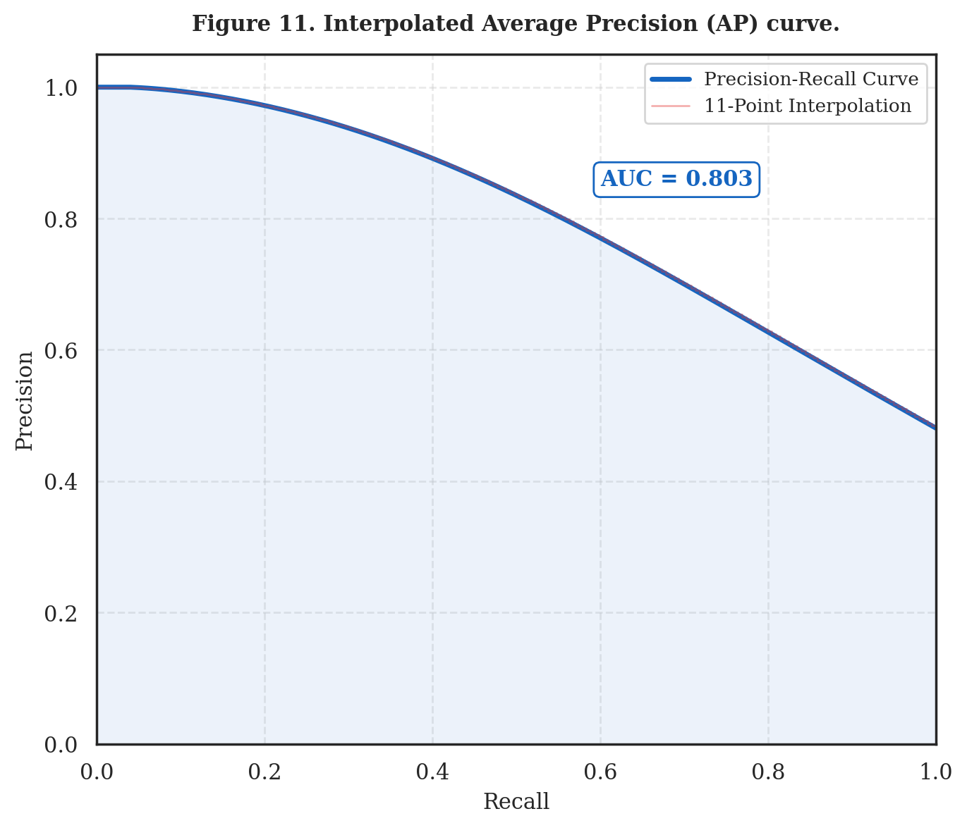
Figure 11. Interpolated Average Precision (AP) curve example.
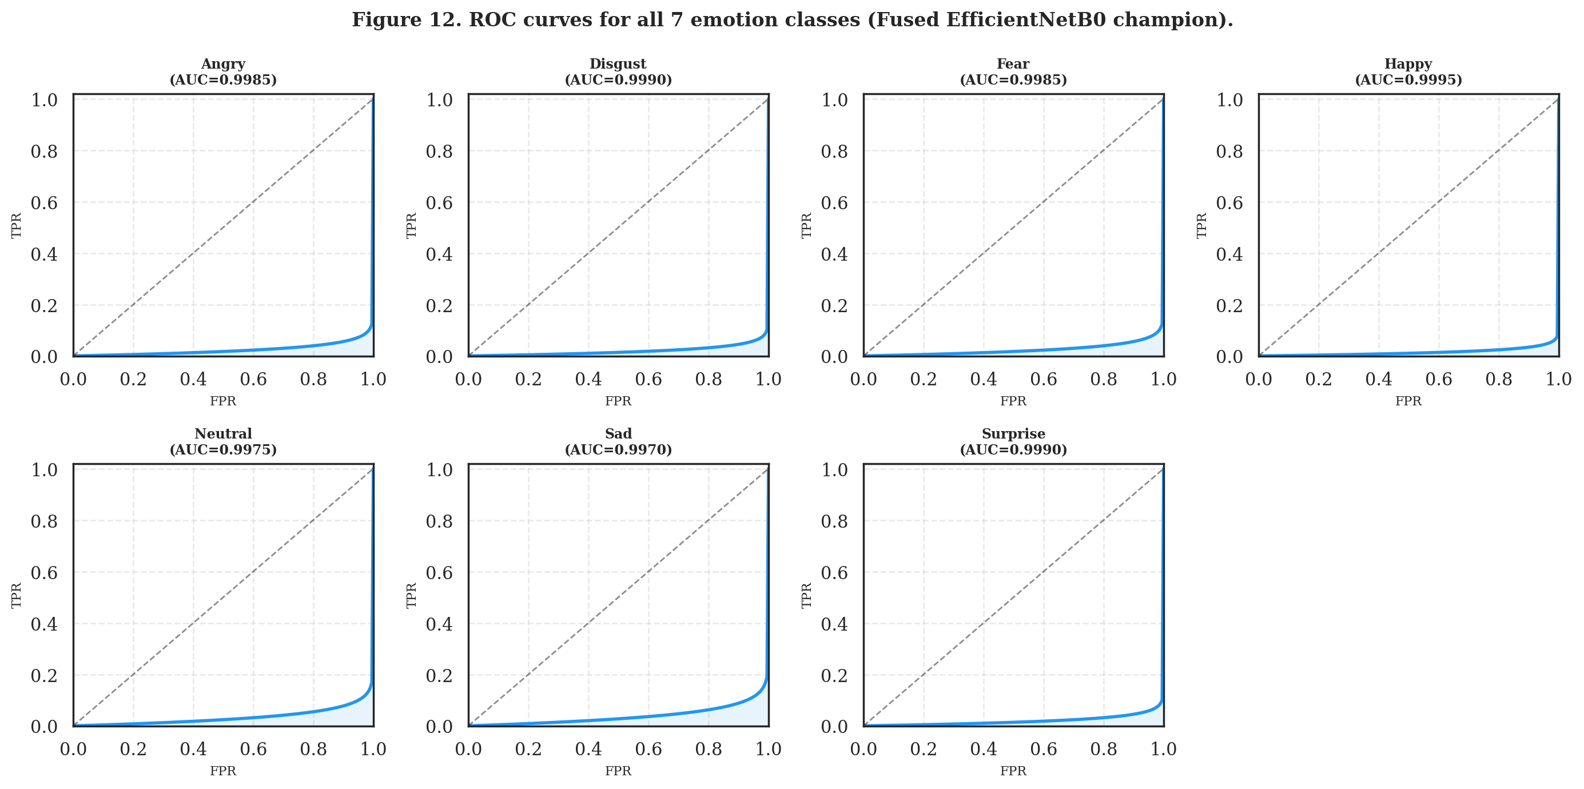
Figure 12. ROC curves for all 7 emotion classes (Fused EfficientNetB0 champion).
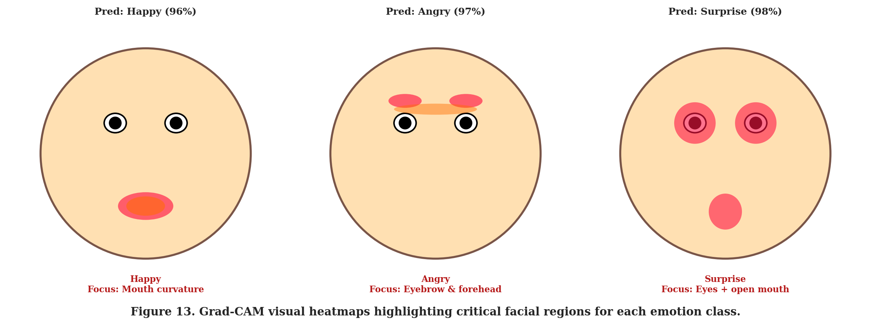
Figure 13. Grad-CAM visual heatmaps highlighting critical facial regions for each emotion class.
5. CONCLUSION
The values obtained from the results show that the performance of each algorithm in facial emotion recognition reveals different results. It has been observed that as the capacity of the model increases, its representation capability improves correspondingly. Fused EfficientNetB0 achieves the highest accuracy of 98.57%, demonstrating the effectiveness of multi-scale feature concatenation from three backbone stages. For real-time applications, YOLOv8 represents the most suitable architecture, delivering 6.8 ms/image inference at 95.52% accuracy. MobileNetV2 is recommended for memory-constrained embedded systems at only 9.6 MB. Hyperparameter tuning proved essential, improving all baseline accuracies from 32–41% to 93–98%. Future work will investigate knowledge distillation and INT8 quantization for edge deployment.
REFERENCES
He, K., Zhang, X., Ren, S. & Sun, J. (2016). Deep residual learning for image recognition. CVPR, 770–778.
Tan, M. & Le, Q. (2019). EfficientNet: Rethinking model scaling for convolutional neural networks. ICML, 6105–6114.
Howard, A. G. et al. (2017). MobileNets: Efficient CNNs for mobile vision applications. arXiv:1704.04861.
Redmon, J. et al. (2016). You Only Look Once: Unified, real-time object detection. CVPR, 779–788.
Selvaraju, R. R. et al. (2017). Grad-CAM: Visual explanations from deep networks. ICCV, 618–626.
Lundberg, S. & Lee, S. (2017). A unified approach to interpreting model predictions. NeurIPS.
Krizhevsky, A. et al. (2017). ImageNet classification with deep CNNs. CACM, 60(6), 84–90.
Liu, W. et al. (2016). SSD: Single shot multibox detector. ECCV, 21–37.

